PALM SPRINGS FIRE DEPARTMENT

Appendix “S”

VEGETATION MANAGEMENT IN VERY HIGH FIRE HAZARD SEVERITY ZONES

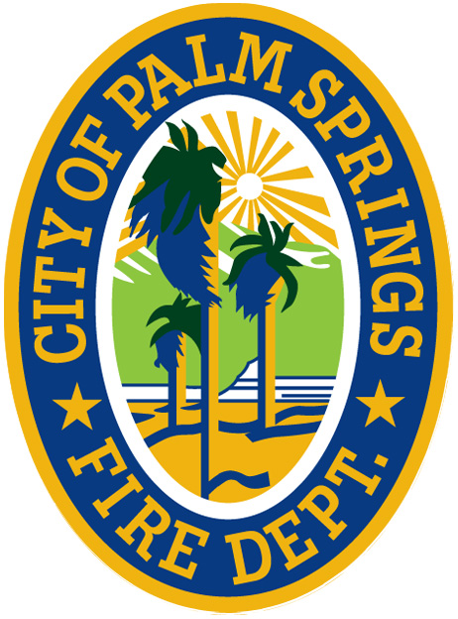

PALM SPRINGS FIRE DEPARTMENT
300 NORTH EL CIELO ROAD
PALM SPRINGS, CA 92262

COMMUNITY RISK REDUCTION CONTACT INFORMATION:
OFFICE: 760.323.8181
EMAIL: communityriskreduction@palmspringsca.gov

TABLE OF CONTENTS

1.1 INTRODUCTION 3

1.2 PURPOSE 3

1.3 PENALTY 3

1.4 CLEARANCE REQUIREMENTS/FUEL MODIFICATION 3-5

1.1 INTRODUCTION
Vegetation management has proven to be a major factor in reducing the chances of buildings igniting from wildfires and from wildland areas being ignited from burning buildings. When combined with special building construction features, the chances of ignition are further reduced. Fire and Building Department agencies adopt local and state codes that require vegetation management and special construction features. The Vegetation Management Guideline increase requirements for brush clearance and fire safety in the Very High Fire Hazard Severity Zones (VHFHSZ).

1.2 PURPOSE
This guideline establishes appropriate safety measures necessary to mitigate the occurrence of fires.

1.3 PENALTY
A first violation of this section shall be an infraction punishable by a fine not to exceed $250. A second and all subsequent violations of this appendix shall be subject to prosecution as an infraction or prosecution as a misdemeanor punishable by a fine not to exceed $1,000, by imprisonment in the County Jail for a period not to exceed six months, or by both such fine and imprisonment. In addition, to the aforementioned penalties, any violator convicted under this appendix, which resulted in a fire, may be liable for any civil cost recovery associated with the fire, as permitted by law.

1.4 CLEARANCE REQUIREMENTS
Owners of property located in the Very High Fire Hazard Severity Zone (VHFHSZ) shall maintain their property in accordance with the 2022 California Fire Code and Palm Springs Fire Department Vegetation Management Guideline. Year-round compliance shall be maintained as described below on all native brush, weeds, grass, trees, and hazardous vegetation within 200 feet of any structure/buildings, whether those structures are on the owner’s property or adjoining properties, and within 10 feet of any combustible fence or roadway/driveway used for vehicular travel.

- Areas within 200 feet of structures and/or 10 feet of roadside surfaces or combustible fence: Grass shall be cut to three inches in height. Native brush shall be reduced in quantity to three inches in height. This does not apply to individual native shrubs spaced a minimum of 18 feet apart, provided such shrubs are trimmed up from the ground to 1/3 of their height with all dead material being removed (see diagram below).

- For trees taller than 18 feet, trim lower branches so no foliage is within six feet of the ground, and remove all dead material. For trees and shrubs less than 18 feet, remove lower branches to 1/3 of their height, and remove all dead material (see diagram below).

- Trees shall be trimmed up so the foliage is no closer than 10 feet from the outlet of a chimney (see diagram below).

- All roof surfaces shall be maintained free of substantial accumulation of leaves, needles, twigs and any other combustible matter. Maintain five feet of vertical clearance between roof surfaces and portions of overhanging trees (see diagram below).

- All cut vegetation and debris shall be removed in a legal manner. Cut vegetation may be machine processed (i.e., chipped) and spread back onto the property at a depth not to exceed three inches within 30 feet of structures and six inches beyond 30 feet of structures. In addition, spread material shall not be placed within 10 feet of any usable roadside.

- Use of metal cutting blades for grass or brush clearance shall be limited to those which are non-ferrous/non-sparking.

- Brush clearance cannot be done on red flag days, when fire weather conditions are at their peak.

- Individuals engaged in brush clearance operations shall not engage in any other activities during their actual clearance of grass or brush.

- An approved 2-A two (2) gallon water fire extinguisher, or a pressurized garden hose with attached nozzle shall be within 10 feet of any grass or brush clearance operation, to quickly extinguish a small fire before it burns out of control.

- Where a gasoline container is present at the site of the grass or brush clearance operation, a minimum 4A 60BC dry chemical fire extinguisher shall be within 10 feet of the brush clearance operation.

- A cell phone capable of dialing 9-1-1 shall be charged and readily accessible to the grass or brush clearance operation.

The above general requirements also apply to landscape vegetation.

VEGETATION MANAGEMENT IS A YEAR-ROUND RESPONSIBILITY
Clear Early, Clear Often.

